Image | Title- (25 character limit) | CC | Body (90 character Limit) | CC
 | Get 75¢ OFF of TAJÍN! | 22 | A sprinkle of TAJIN makes fruits & veggies as unique as you are! Fast, delish & oh so you. | 90
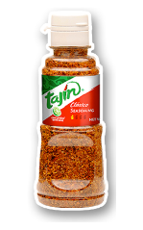 | Click 4 a flavor secret! | 23 | Fruits & veggies just got better! Try it, like it & share; you could win up to $10,000! | 87
 | Get the flavor they love! | 25 | Fruits get sweeter & veggies become favorites with mom’s flavor boost -TAJIN! | 78
 | Share the flavor secret! | 24 | Sprinkle on TAJIN’S & enjoy a healthy boost to your kitchen cred! Get 75¢ OFF of TAJÍN! | 88

